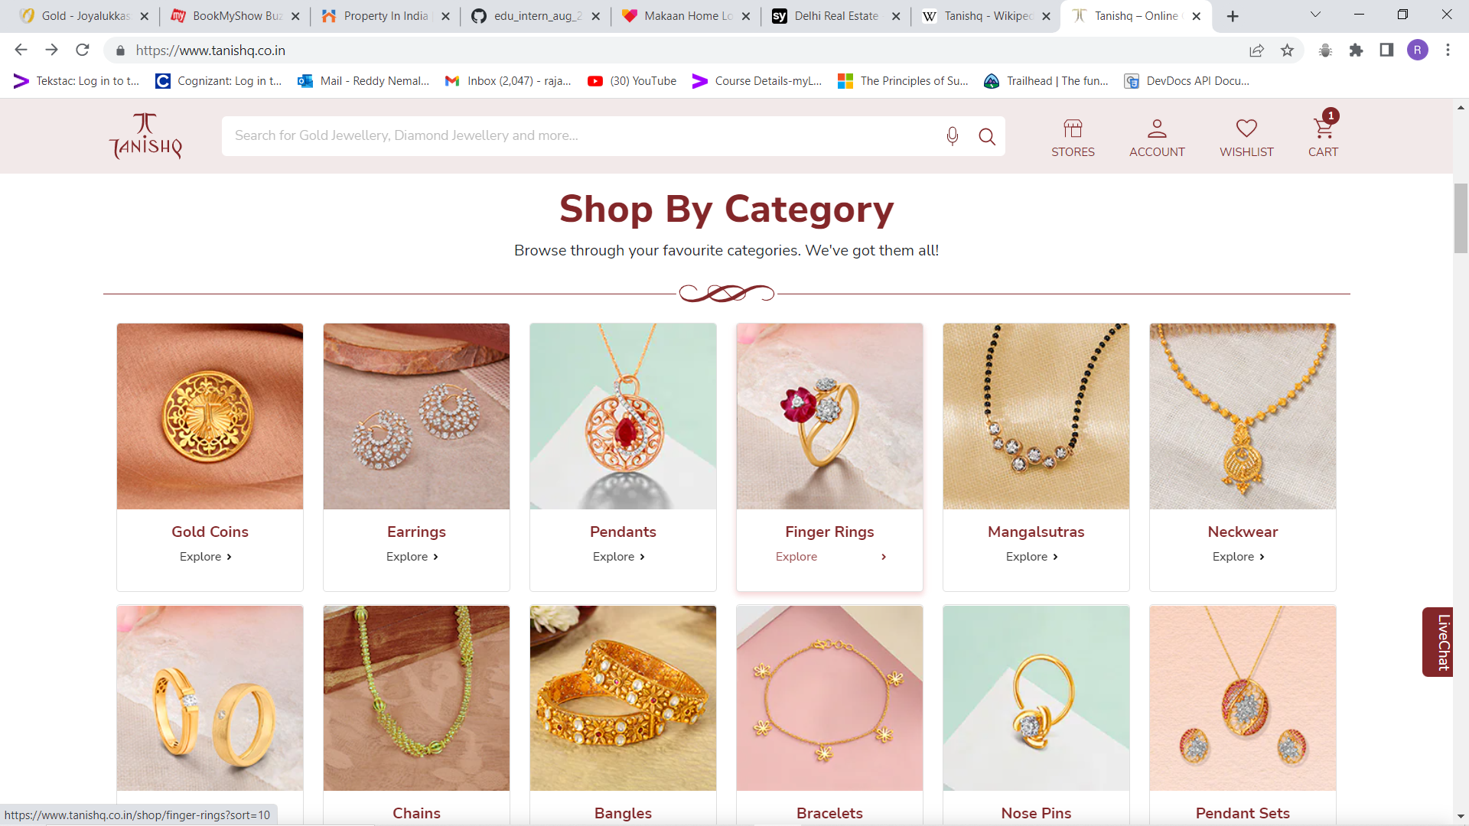 **PROJECT-NAME: TANISHQ**

**\*OVERVIEW:** **Tanishq** is an Indian Jewellery brand and a division of Titan Company . In this website it mainly consists of collection of various types of jewellery items categorized over wide range of genres . one of the best sites featured to offer end to end services to the customers .

1. **HOME PAGE** :

Home page contains mainly

1. logo
2. search bar
3. stores, account , wish list and cart icons
4. navigation bar showing the list of various types of jewelleries
5. sections showing shop by categories , genders and e.t.c
6. **STORE LOCATOR**

A feature showing all the stores across india.

1. **Account details.**

Feature showing all the details of an individuals account

1. **Wish list**

Page showing the items marked as favourite.

1. **Cart**

Page showing the items added to the cart and having the checkout option followed by the payment gateway.